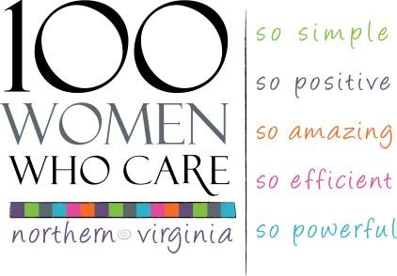
100 Women Who Care NoVA
Team Registration & Commitment Form

NAME – Partner #1
STREET ADDRESS
CITY, STATE, ZIP
PHONE
EMAIL
NAME – Partner #2
STREET ADDRESS
CITY, STATE, ZIP
PHONE
EMAIL

With our signatures below, we are agreeing that the information we provide above is accurate and true. We are pledging to participate in 100 Women Who Care, and are making a “partnership” commitment to contribute $400 each calendar year ($100 quarterly) to local nonprofit organizations serving the Northern Virginia region. We agree to donate each quarter to the nonprofit organization selected by the group’s majority vote. If one of us is unable to attend a quarterly meeting, our check will be sent with the other attending member or mailed as requested after the meeting, or submitted online via credit card through Grapevine. We acknowledge that as a team, we have just one vote for a charity per team. We acknowledge that photographs and videos taken at events and meetings may include our images and may be used in promotional materials for 100 Women Who Care NoVa and/or
100 Who Care Alliance.

Signature of partner #1 date ___________________________________________

Signature of partner #2 date ___________________________________________

We understand our personal contact information is strictly confidential and we understand it will not be shared or distributed to an outside third party without our expressed consent. We understand that 100 WWC NoVa may choose to publish a Membership Directory and if so, we agree that our contact information be included in that directory. Yes_________ No___________

